**Automate your Keysight Test Instruments Using Python 2.7**

This document provides a step by step guide showing how to communicate with test instruments using Python 2.7. The following steps will be reviewed.

1. Install required software applications
   1. Install Keysight IO Libraries
   2. Install Keysight Command Expert
   3. Install Anaconda (Python 2.7)
   4. Install PyVisa
   5. Install Python.NET
2. Verify Instrument Connectivity using Keysight IO Libraries
3. Communicate w/ Test Instruments using SCPI Commands
4. Additional Test and Measurement Python Resources

**Step1) Install Software**

1. **Install Keysight IO Libraries**
   1. Download Keysight IO Libraries
   2. [**www.keysight.com/find/iolib**](http://www.keysight.com/main/software.jspx?cc=US&lc=eng&ckey=1184883&nid=-33002.977662&id=1184883)
   3. Install Keysight IO Libraries
2. **Install Keysight Command Expert**
   1. Download Keysight Command Expert
   2. [**www.keysight.com/find/commandexpert**](http://www.keysight.com/main/software.jspx?ckey=2151326&lc=eng&cc=US&nid=-33002.992473&id=2151326&pageMode=CV)
   3. Install Keysight Command Expert
3. **Install Anaconda**
   1. Download 32 bit version of Anaconda for Windows. **Note: Keysight Command Expert supports 32 bit versions of Python.**
   2. [**http://continuum.io/downloads**](http://continuum.io/downloads)
   3. Select the installation package highlighted below

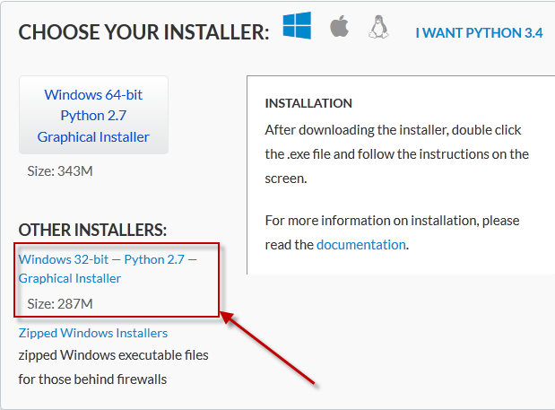

* 1. Install Anaconda Python 2.7 32-Bit for Windows

1. **Install PyVISA**
   1. Open Anaconda Command Prompt
      1. Start -> All Programs -> Anaconda Command Prompt

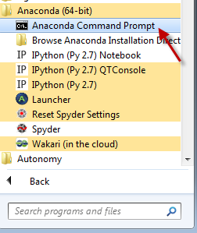

* 1. View installed packages
     1. Type ‘conda list’ at the Anaconda Command Prompt
     2. Press Enter
     3. The installed packages should display in the Command Prompt as shown below.

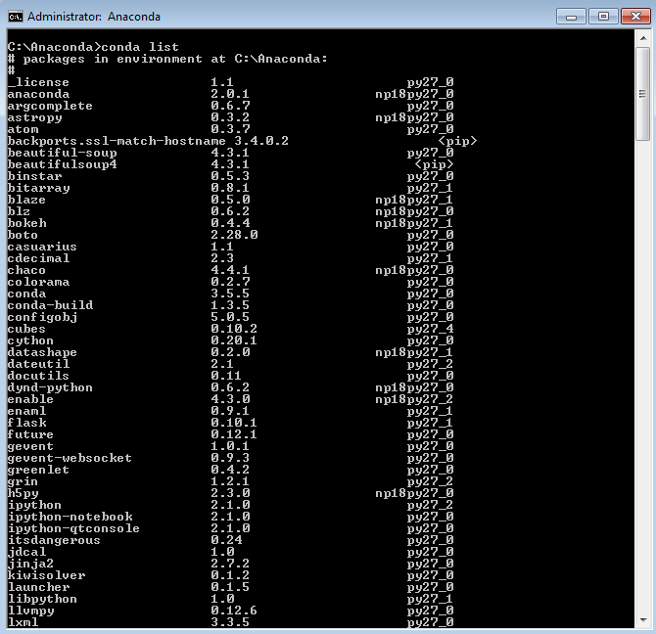

* 1. Install Pyvisa
     1. Type ‘pip install pyvisa’ at Anaconda Command Prompt
     2. Press Enter
     3. The installation for Pyvisa should proceed as shown below

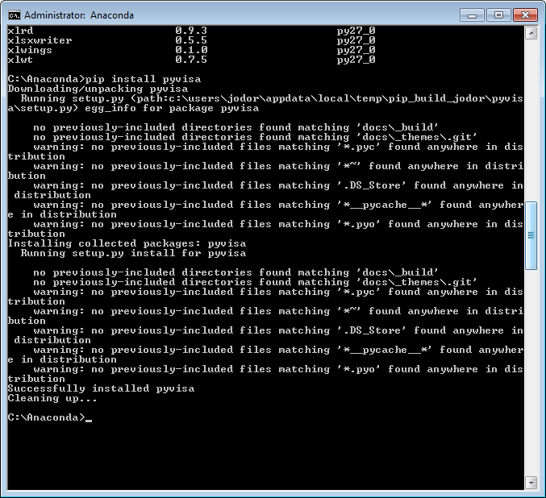

1. **Install Python.NET**
   1. Type ‘pip install –pre pythonnet’at Anaconda Command Prompt

Note: ‘-‘ before pre is 2x’—‘ as below

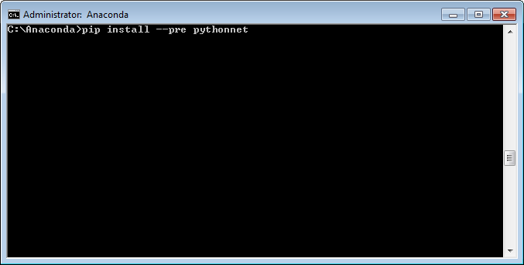

* 1. The installation for Python .NET should proceed as shown below

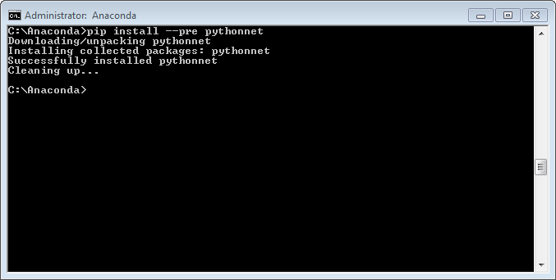

**Step 2) Verify Instrument Connectivity using Keysight IO Libraries**

1. Choose a physical connection that works best for you. Many instruments today support remote connectivity over USB, LAN, GPIB, or PCIe. Determine which IO interface your instrument has and connect your instrument now. Consult your instrument’s user’s guide for additional instruction.
2. Launch Connection Expert, which is part of the Keysight IO libraries: Start > All Programs > Keysight Connection Expert

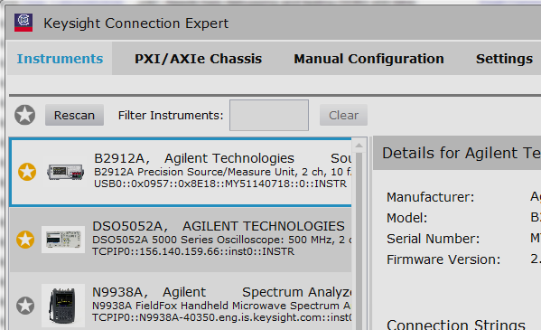

Please reference the IO Libraries Documentation within the IO Libraries for help getting connected.

1. Once your instrument is properly configured, it will show up under “Instruments” tab. You can select the instrument entry and see its VISA address within the Details to the right. We will use this VISA address in our VBA program.

**Step 3) Communicate w/ Test Instruments using SCPI Commands**

1. **Copy and Paste the following test code into the Spyder (Python) IDE**

**# Python for Test and Measurement**

**# Example programs avaialable at 'ftp://ftp.keysight.com/callpub6/callpub6/MISC/Keysight_Python'**

**# import python modules**

**import visa**

**try:**

**#Open Connection**

**rm = visa.ResourceManager('C:\\Program Files (x86)\\IVI Foundation\\VISA\\WinNT\\agvisa\\agbin\\visa32.dll')**

**#Connect to VISA Address**

**#LAN - VXI-11 Connection: 'TCPIP0::xxx.xxx.xxx.xxx::inst0::INSTR'**

**#LAN - HiSLIP Connection: 'TCPIP0::xxx.xxx.xxx.xxx::hislip0::INSTR'**

**#USB Connection: 'USB0::xxxxxx::xxxxxx::xxxxxxxxxx::0::INSTR'**

**#GPIB Connection: 'GPIP0::xx::INSTR'**

**myinst = rm.open_resource("TCPIP0::localhost::hislip0::INSTR")**

**#Set Timeout - 5 seconds**

**myinst.timeout = 5000**

**#*IDN? - Query Instrumnet ID**

**myinst.write("*CLS")**

**myinst.write("*IDN?")**

**print myinst.read()**

**#Close Connection**

**myinst.close()**

**print 'close instrument connection'**

**except Exception as err:**

**print 'Exception: ' + str(err.message)**

**finally:**

**#perform clean up operations**

**print 'complete'**

1. **Copy the VISA address string from the Connection Expert in Step 2) to the line below**

**myinst = rm.open_resource("*TCPIP0::localhost::hislip0::INSTR*")**

1. **Execute Python script by running program as shown below**

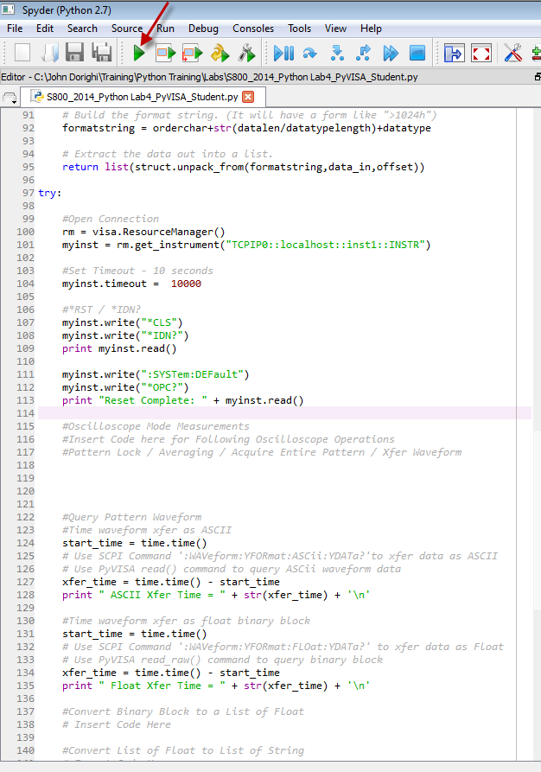

**Additional Python Test and Measurement Resources**

Here are links to an on line Python course, the steps reviewed in this document are highlighted in Video 1, Video 2, and Video 13. Additional videos provide background details on Python programming syntax.

Video 1: Introduction - <https://youtu.be/q7uosQJiAII>

Video 2:  Installation Prerequisites - <https://youtu.be/82LNsTvRHiA>

Video 3:  Getting Started w/ Python - <https://youtu.be/q8lbqaOb9-g>

Video 4:  Python Variable Types - <https://youtu.be/7eivyIRCHmQ>

Video 5:  Python Lists Tuples - <https://youtu.be/lxmrK85_v9c>

Video 6:  Basic Math Operations - <https://youtu.be/NBKlzd4-4kc>

Video 7:  Looping and Logical Operations: <https://youtu.be/HUfa49-UgAk>

Video 8:  Function Definitions - <https://youtu.be/NAF5y_-ROrg>

Video 9: Basic File IO - <https://youtu.be/dh9mPVE6pEk>

Video 10:  Exception Handling - <https://youtu.be/f3IhYUTDgZo>

Video 11: Array Generation and Plotting - <https://youtu.be/EYpKLYgySOA>

Video 12:  Connecting to Instruments - <https://youtu.be/THjdEyX8SdI>

Video 13:  Python PyVISA - <https://youtu.be/hCYoVx31ekc>

Video 14:  Generating SCPI Commands - <https://youtu.be/zqT3dzKoiAE>

Video 15:  Writing a Program SCPI PyVISA - <https://youtu.be/MoLC1qmpzVI>

Video 16:  Binary Blocks and PyVISA - <https://youtu.be/F-8OlYrgJh0>

Video 17: Adding Program Structure - <https://youtu.be/oGc7ZUja1mc>

Example programs for the videos can be downloaded from the FTP site below.

<ftp://ftp.keysight.com/callpub6/callpub6/MISC/Keysight_Python/>